Request for Proposals
Event Coordinator Services
July 26, 2018
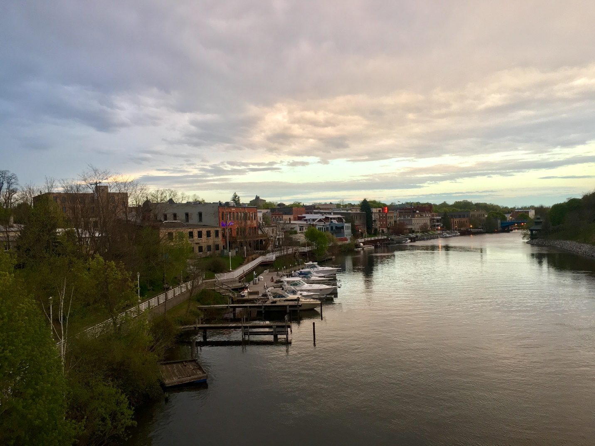

Overview
Manistee Downtown Development Authority (DDA) is soliciting competitive proposals from qualified independent contractors interested in assisting, managing and developing events for Downtown Manistee. The successful contractor will work under the general supervision of the Executive and Economic Development Director for the Manistee DDA. It is the DDA’s intent to enter into a three-year agreement with an annual review after each year.

Objective and Scope of Work
The Manistee DDA is seeking qualified independent contractors to provide event coordinating services. The contractor will work with and take direction from DDA Executive and Economic Development Director for each existing and established event within the DDA District. The contractor will manage the execution of all aspects of DDA events including but not limited to:
- Planning
- Fundraising
- Vendor and supplier procurement and management
- Fundraising and Sponsor Relations
- Onsite Day of coordination
- Overall event management logistics
- Budget management
- Marketing
- Implementation
- Volunteer Support
- Permit Applications and Licensing Requirements
- Post Event Evaluation and analysis

Events
The following is a current representation of the revenues generated from sponsorships and ticket sales, and expenses incurred for existing events. It is the DDA’s expectation that the selected contractor will increase revenues and/or provide options to enhance the events.
Frostbite Chili Crawl – February
Downtown businesses compete in a chili crawl and participants vote on their favorite chili with an afterparty at a local restaurant to announce the winner.
Sponsorship Revenue - $1,100
Expense - $960
Downtown Manistee Wine and Chocolate Walk – May
12 Downtown businesses participate as either a chocolate or wine tasting location.

Sponsorship Revenue - $2,000
Ticket Sales - $2,930
Expense - $4,200
TGIF Manistee – June
A Free Family friendly event on River Street with live music, games, entertainment, vendors and sidewalk sales.
Sponsorship Revenue - $650
Expense - $700
TGIF Manistee – August
A Free Family friendly event on River Street with live music, games, entertainment, vendors and sidewalk sales.
Sponsorship Revenue - $650
Expense - $700
Sidewalk Sales – August
Downtown businesses hold annual sidewalk sales, the DDA’s contribution is for advertising.
Expense - $500
Hops & Props – September
A Signature Manistee Event featuring classic wooden boats and Michigan craft beer, cider, and wine. Over 100 beers from 35 Michigan breweries, an assortment of Classic Century Boats, and music.
Sponsorship Revenue - $13,000
Ticket Sales - $35,000
Expense - $26,200
Boos, Brews, & Brats – October
Features a kids tent and downtown trick or treating, followed by a pub crawl and beer tent.
Sponsorship Revenue - $3,000
Ticket Sales - $2,275
Expense - $3,840
Men’s and Ladies’ Night – December
On two separate nights businesses have specials, drawings, and entertainment. The DDA contributes to this event with advertising.
Sponsorship Revenue - $1,100
Expense - $850
Old Victorian Weekend and Sleighbell Parade – December
An entire weekend of excitement including the Victorian Sleighbell Parade with horse drawn entries, bagpipers, reindeer meet and greet and carolers elegantly dressed in Victorian style attire. The highlights of the parade are the draft horses pulling a 30 foot Christmas tree down River Street followed by a beautiful display of luminaries, caroling, and the lighting of the tree.
Sponsorship Revenue - $18,750
Expense - $17,430

Key Expectations
The contractor will be expected to exhibit the following skills:
Effective Communication: Event coordinator will work closely with volunteers, listening to needs and presenting ideas and solutions. They will also work with suppliers, vendors, contractors, employees, city employees, sponsors, volunteers, and many other parties at the same time. Customer service and interpersonal skills are required.
Calm Under Pressure: Remain calm during crisis and the high pressure of an event in progress.
Negotiations Skills: Demonstrate strong negotiation skills to work out prices with clients and contractors.
Organization: Stay focused and organized so that the event goes off without a hitch.
Problem-Solving Skills: Act quickly to solve a concern or opportunity.
Fundraising: Able to raise the necessary funds to carry out the event in a professional manner.

Proposal Qualification Requirements
All Proposals submitted for evaluation must include but are not limited to the following information.
- Individual Background – Please provide information about yourself, history, credentials, principal place of business and contact information.
- Responding independent contractors are encouraged to share examples of similar projects and provide an explanation of what could be considered including materials used and creative process.
- Proof of Liability Insurance.
- Cost – Identify the estimated cost or cost structure to complete this work for the 2018-2019 Fiscal Year (July 1, 2018 to June 30, 2019).
Evaluation of Proposals
Proposals will be evaluated and ranked. Evaluation criteria with assigned weights are as follows:
- Completeness of Proposal – 20 points
- Experience – 20 points
- Cost – 20 points
- Location of business (Preference will be given to local applicants) – 10 points

Inquiries and Instructions for Proposal Submission
Two (2) copies of the proposal must be submitted. Submissions are due by August 24, 2018. An electronic file of all submissions is also requested. All inquiries and submissions relating to the proposal should be directed to:
Manistee DDA
Tyler Leppanen
70 Maple St
Manistee, MI 49660
Tyler.leppanen@manisteedowntown.com or (616)402-5684
Acceptance of Proposal
Manistee DDA will evaluate all proposals to determine acceptance or rejection of the proposal. Manistee DDA reserves the right to reject any or all bids for any reason.

Pursuant to this RFP a contract will be executed and signed

Procurement Rules and Procedures
Manistee DDA will award a contract in reliance upon the information contained in proposal submitted in response to the RFP. Manistee DDA will be legally bound only when and if there is a definitive signed agreement with the awarded contractor.
The successful Contractor who has his/her proposal accepted may be required to answer further questions and provide further clarification of his/her proposal and responses.
Receiving this RFP or responding to it does not entitle any entity to participate in services or transactions resulting from or arising in connection with this RFP. Manistee DDA shall have no liability to any person or entity under or in connection with this RFP.
No oral modifications or amendments to this RFP or any resulting contract shall be effective, but such may be modified or amended by written agreement signed by the parties. If it becomes necessary to revise any part of this RFP, an addendum will be provided to all who received an RFP.

